

Assignment 1

Addison Douglas



October 7, 2022

Everett Community College

axdouglas@students.everettcc.edu

# Description

This assignment asked for the creation of two programs. One which would ask the user for a year and age. Then calculate what year they would turn that age based on the given birthday. The other would calculate the average of 5 grades and give a letter grade based on the average.

# The Code (if more than one question, then specify the question and paste the code of every question)

***Code for Birthday Wizard***

/**

*

*/

package cs141.axdouglas;

/**

* Name : Addison Douglas

* Section: A

* Program Name: Birthday Wizard

*

* Description: This program takes two integer from the user, one being their birth year

* and one being an age. It then calculates what year they would be that age in by adding age and

* birth year together. Then that new calculated year is printed to the user.

*

*/

import java.util.Scanner;

/**

* @author axdouglas

*

*/

public class BirthdayWizard {

/**

* @param args

*/

public static void main(String[] args) {

// TODO Auto-generated method stub

System.out.println("My name is Addison Dougas");

System.out.println("Program 1: Birthday Wizard");

System.out.println("-----------------------");

Scanner userInput = new Scanner(System.in);

System.out.println("What year were you born?");

int yearOfBirth = userInput.nextInt();

System.out.println("Choose an age in years?");

int age = userInput.nextInt();

int newYear = yearOfBirth + age;

System.out.format("You will turn %d in the year %d",age, newYear);

userInput.close();

}

}

***Code for grade calculator***

/**

*

*/

package cs141.axdouglas;

/**

* Name : Addison Douglas

* Section: B

* Program Name: Grade Calculator

*

* Description: This program uses scanner to get 5 grades from the user, the grades being

* 0-100. It then adds those all up and divides by 5 to get the average. This average is then

* sent through an if statement to decide what the letter grade would be. The average

* and the letter grade is then output to the user.

*/

import java.util.Scanner;

/**

* @author axdouglas

*

*/

public class GradeCalculator {

/**

* @param args

*/

public static void main(String[] args) {

// TODO Auto-generated method stub

System.out.println("My name is Addison Dougas");

System.out.println("Program 1: Grade Calcalculator");

System.out.println("-----------------------");

Scanner userInput = new Scanner(System.in);

System.out.println("Enter five grades(0-100)");

double grade1 = userInput.nextInt();

double grade2 = userInput.nextInt();

double grade3 = userInput.nextInt();

double grade4 = userInput.nextInt();

double grade5 = userInput.nextInt();

double gradeAverage = (grade1 + grade2 + grade3 + grade4 + grade5) / 5.0;

char letterGrade;

if(gradeAverage<=100 && gradeAverage >= 90) {

letterGrade = 'A';

}

else if(gradeAverage<=80 && gradeAverage >= 89) {

letterGrade = 'B';

}

else if(gradeAverage<=70 && gradeAverage >= 79) {

letterGrade = 'C';

}

else if(gradeAverage<=60 && gradeAverage >= 69) {

letterGrade = 'D';

}

else {

letterGrade = 'F';

}

System.out.format("The avrage of the 5 grades is %.2f %n", gradeAverage);

System.out.format("The letter grade is: %c%n", letterGrade);

}

}

# The output

Screenshots of your runs. 3 screenshots of 3 scenarios you tried in your program.

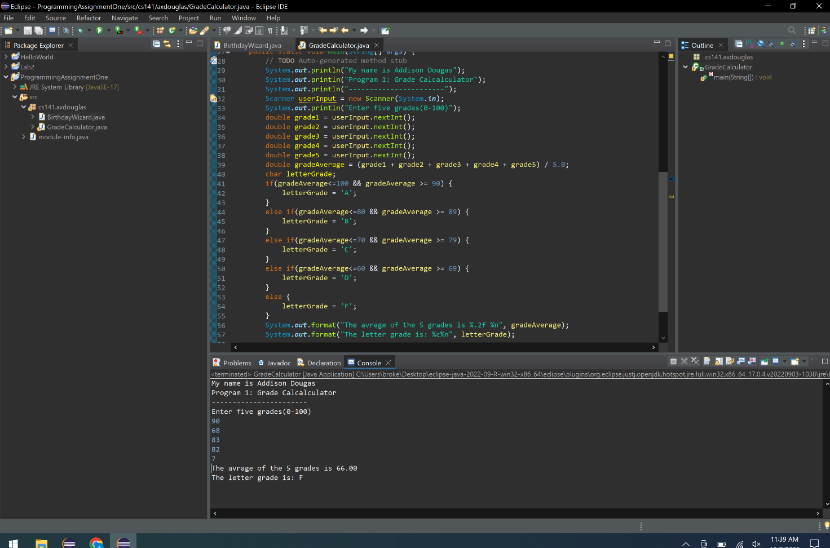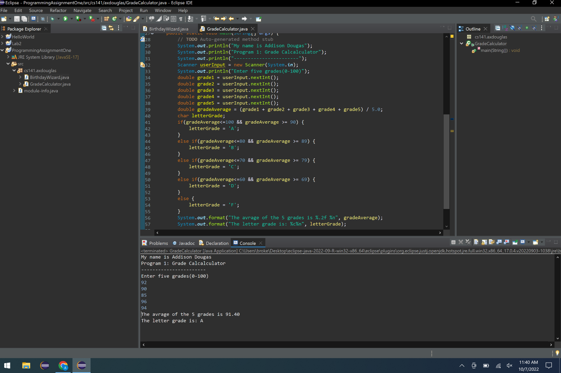

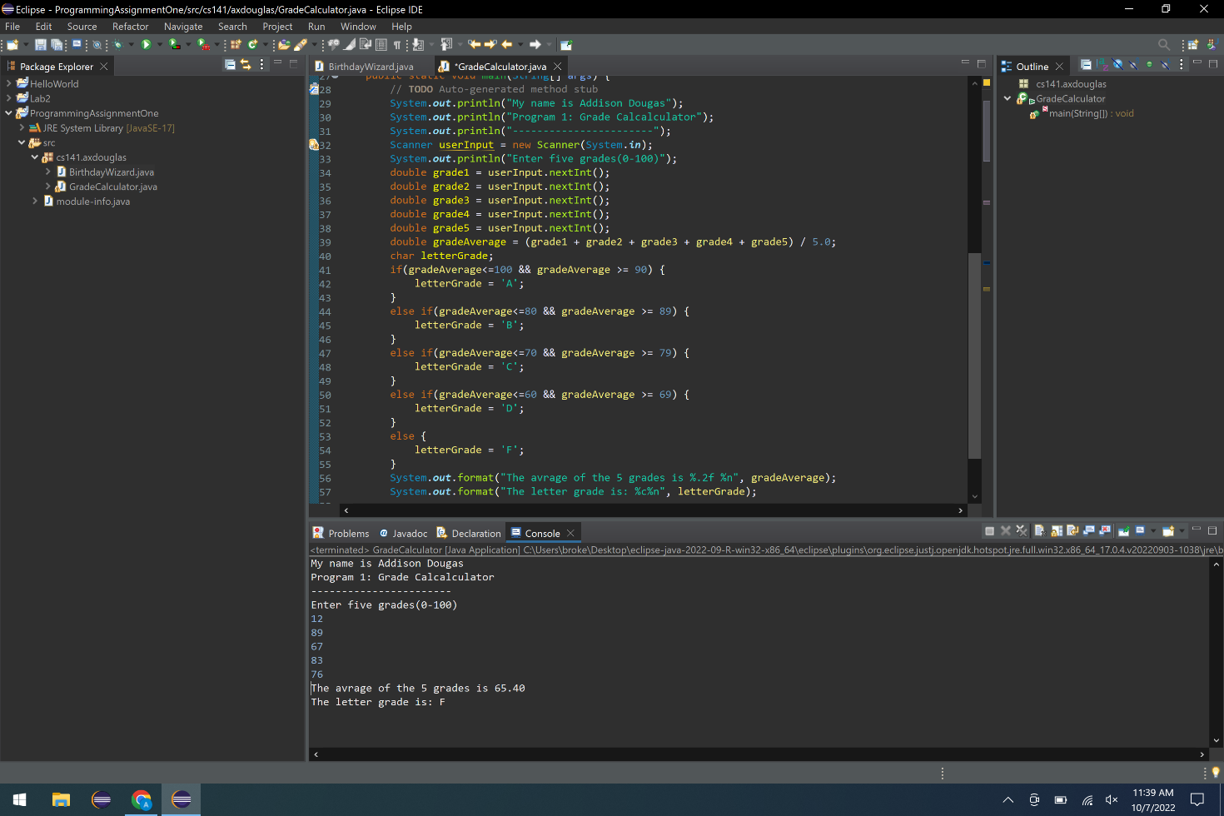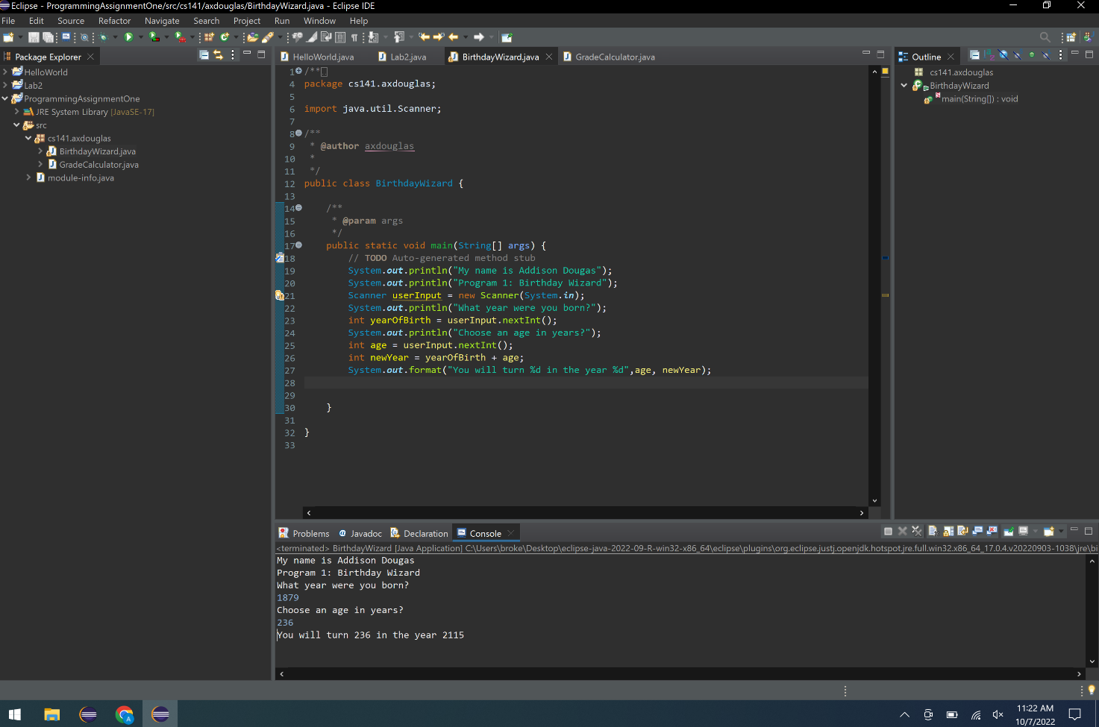

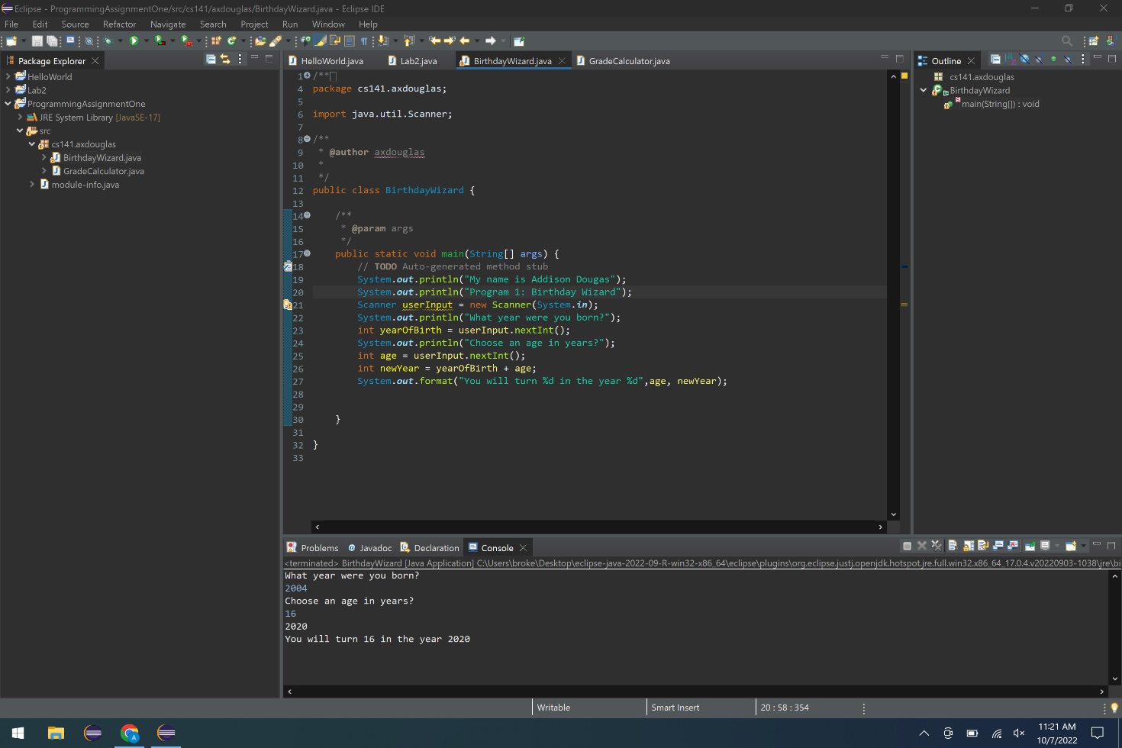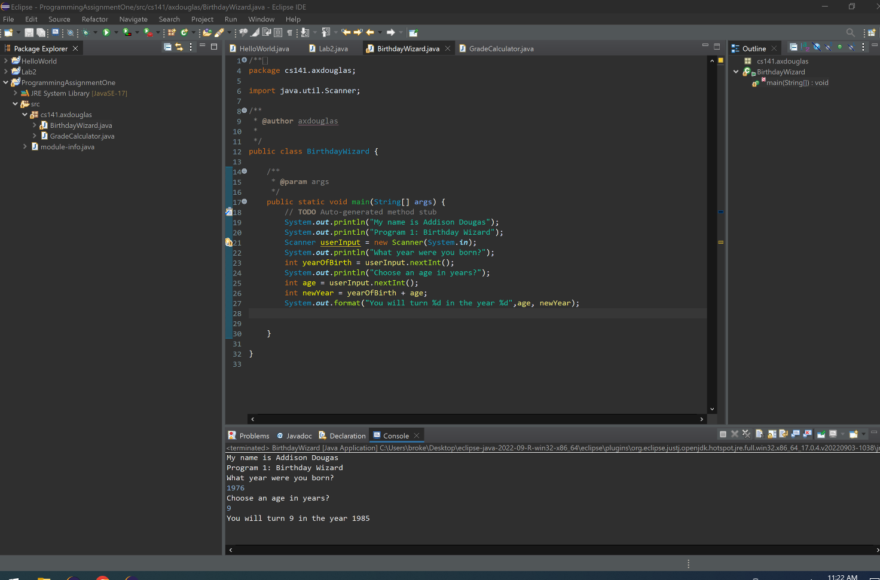

# Comments/Notes (Extra Credit)

The comments or the notes section is if you wanted extra credit. This could be struggles you have come over while doing your program, or additions you wanted to highlight so I notice while grading…